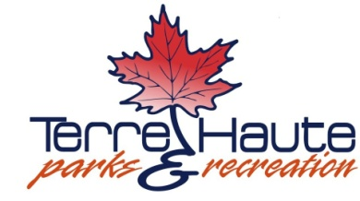

**Park Board - Special Call**

**Wednesday, January 15, 2025**

**3:45pm**

**Torner Community Center**

**Deming Park**

Special Call

1. Call to Order

2. Election of Park Board Officers

3. Adjournment